When Razor files compiled, the codes are changed into html view.

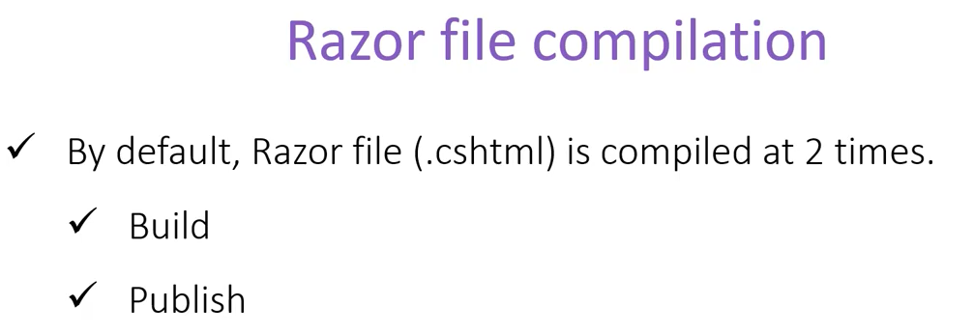

This creates a problem during development since we want to test out different changes. Cause it only compiles during build and publish and after that any changes wont be reflected.

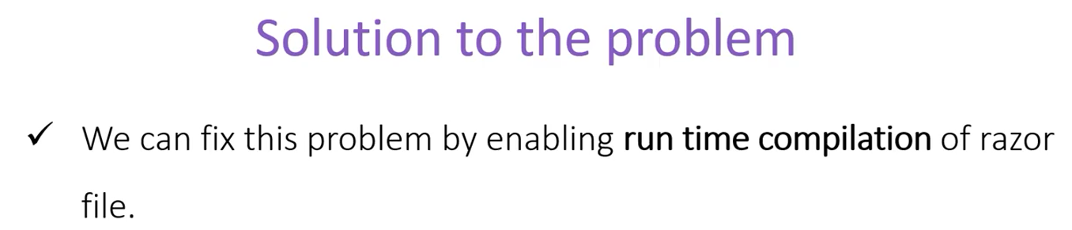

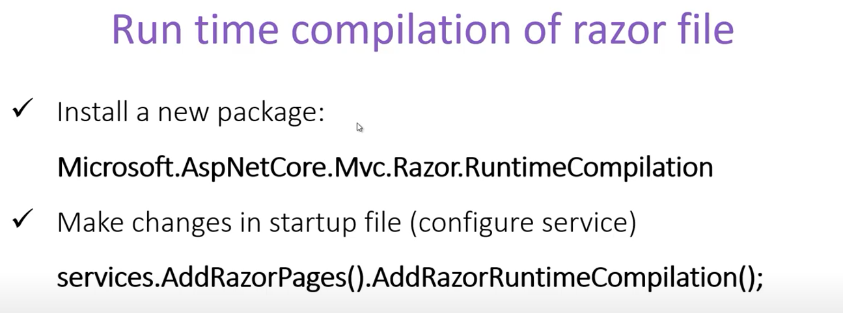

We can add this option conditionally though,

